Final Documentation – Smart Hotel Management System (SHMS)

Student Name: Mahmoud Ibahem Mahmoud

Tools: Visio , word
Year: 2025

- Introduction

The Smart Canteen Management System (SCMS) is a digital platform designed to automate and manage all daily operations of a modern school or university canteen. The system helps students and staff order meals, manage payments, view menus, and track order status, while also supporting canteen administrators in managing inventory, staff, and sales reports.

- Objectives

Document the system design preparation , tools and diagrams
administrators in managing inventory, staff, and sales reports.
Provide admin dashboards and reports.

7. UML Diagram

Use case :

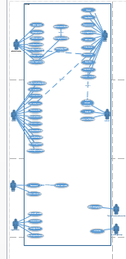

Actors : user , administrator , cashier , system , stuff , supervisors , Teatcher and students club , payment gateway

Activity :
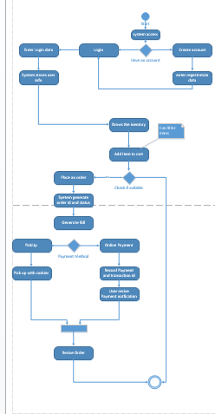

Sequence :
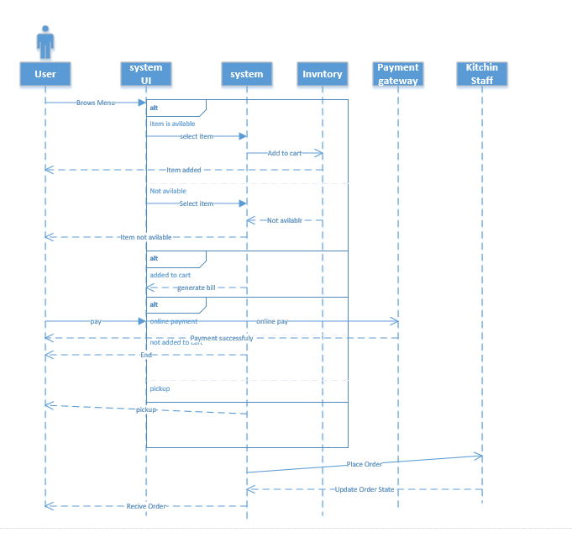

ERD :

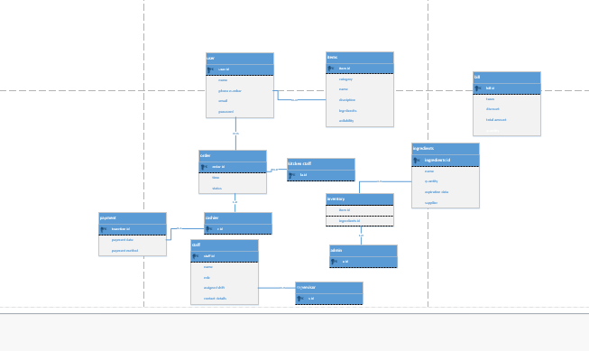

8. JIRA Documentation

SA - Backlog - Jira (atlassian.net)

9. GitHub

https://github.com/ssttrrss/SA.git

